Resume

The Club at Cobble Creek

Board Of directors 2023 Elections

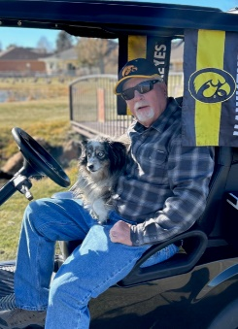

Nick Parrott

3825 Mc Masters Place

Montrose, CO. 81403

(H)(970) 615-7456 (Cell) (303 638-0448

E-mail: Nlparr0121@msn.com

Education:

William Penn College, Oskaloosa Iowa

Business Administration/Business Law/Economics

Work Experience:

1974 – 1982 Fisher Controls, International - iowa

Fisher COntrols is a Manufacturer of process control equipment. I started in customer service and moved into being a manager of large special projects, such as, Alyeska Pipe Line, Chevron Refinery, and Saudi Aramco Projects.

1982 – 1988 Fisher Controls, International - texas

During this time, I was part of a project team that managed a product line transfer, was a manager of customer service, and was in a procurement group as a senoir buyer.

1988 – 2020 PCE Pacific / Applied Control Equipment

In 1988 I accepted promotion to work for an exclusive manufacturer sales representative for Fisher Controls and Emerson Automation. I Managed the Inside sales group from 1988 to 1994. In 1994 I accepted a promotion to account manager of outside Sales. I Managed accounts with an annual sales of 10 to 25 Million dollars.

Knowledge and Skills: Throughout my career i attended training classes for contract negotiation, Customer service, and account sales management. I negotiated and managed large special plant and field automation projects.

Cobble Creek Community Member:

I was fortunate with my 47 year career that my employer worked closeley with me in my retirement transition plan. My wife, Pam, and I moved to Cobble Creek community in May of 2017.

I continued to work and covered the Western slope territory and retired May 1, 2020.

Pam and I enjoy this community immensely, and are both heavily involved. I am a part of the food Service committee as well as the pond fish stocking committee through the HOA, and Pam has served on the Cobble Creek ladies golf board as the 9-hole representative and Vice President, and is currently serving on the Angel tree Committee as the dolphin house liason.

Club Member Vision:

As a member of the cobble creek board, I would work to develop, improve and communicate to all members, developers and the local community a framework to convert our club’s capabilities and competencies into a relevant context of our marketplace. I would begin communicating this with the ultimate goal of increasing future capital revenue to the club at cobble creek. It is time to transform Cobble Creek from “good to Great”. this will require rigorous debate with the intent of finding the best answers that will unify us of our individual interests.

